

Software Design Document – Sydney Airbnb Application

Viet My Tran Le s5235877- William Luvant s5287580 - Liangxian Zhao s2869753

Table of Contents

1.0 System Vision 2

1.1 Problem Background 2

1.2 System Overview 2

1.3 Potential Benefits 2

2.0 Requirements 2

2.1 User Requirements 2

2.2 Software Requirements 3

2.3 Use Cases & Use Case Diagrams 3

3.0 Software Design and System Components 12

3.1 Software Design 12

3.2 System Components 12

3.2.1 Functions 12

3.2.2 Data Structures / Data Sources 14

3.2.3 Detailed Design 16

4.0 User Interface Design 17

4.1 Structural Design 17

4.2 Visual Design 18

# System Vision

## Problem Background

The Sydney Airbnb App aims to provide a platform for users to search, analyse, and compare property listings in Sydney, Australia. According to the provided Sydney Airbnb dataset, the app is supposed to help users to make more informed decisions about the properties based on various factors, such as location, price, keywords, cleanliness, and customers’ satisfaction.

What we are planning to do is develop a system, which could lead to a greater organisation. However, the business is lacking in precision and of modernity. Customers cannot search for a property in a specific period, they also cannot filter properties according to their needs such as cleanliness, satisfaction of other customers and certain keyword. Nowadays, people are very picky and are looking for the best comfort possible for a desired price. The best advice is to create an app that allow customers to search for certain properties according to their needs and preferences.

## System Overview

* App displays every property listed by owners.
* App displays every keyword associated with the property.
* App displays the price of each property.
* App displays average rating of each property.
* App allows user to direct message the property’s owner.
* App allows user to send feedback and reviews.
* App analyses the properties’ cleanliness based on customers’ reviews and feedback.
* Customers can request for making changes.
* Customers can browse accommodations by searching for keyword.
* Customers can sort accommodations by price.

## Potential Benefits

* Economy support for owners.
* Improved search accommodation by providing deeper and more precise search.
* Improved decision making among customers by being able to filter exactly their needs.
* Improved satisfaction for customers.
* Enhanced UX/UI regularly by keeping information and interface up to date.
* Improved flexibility by creating direct communication between the owner and the customer.

# Requirements

## User Requirements

As travellers are the main end-user to our app, it is crucial to ensure that their experience with the app is impeccable. Including a user-friendly interface, users should be able to navigate through the app effortlessly, they can enter their travel dates, desired suburbs, any specific keyword for their needs and preferences. In addition, they should be able to explore through all properties listed on the app, they should see all details and information about the properties with their price. Moreover, as stated above, if they are looking for anything, such as a pool, they just need to enter this keyword and the app will display all properties that contain this keyword. If they are curious about the cleanliness of a certain property, they can check other customers’ reviews about it. With this app, user can make more informed decisions and it will be easier for them as well.

## Software Requirements

The software requirements of our app are as follows:  
R1.1. The app shall allow users to input their travel dates and the desired suburb  
R1.2. The app shall display all the available properties listed corresponding to the users’ input   
R1.3. Each property shall display their price and users shall be able to sort properties by their prices  
R1.4. The app shall provide a feature where users can enter a certain keyword, such as pool or garden, and the app shall display all properties listed containing these keywords.  
R1.5. The app shall be able to perform an analysis based on the comments and reviews the customers left on properties. For example, the app shall be able to display all comments about the cleanliness of a property or the satisfaction of customers regarding the property and calculate the average cleanliness or satisfaction with stars.   
R1.6. The app shall allow communication between the owner and the guests (users).

## Use Cases & Use Case Diagrams



|  |  |
| --- | --- |
| Use Case ID: | 1 |
| Use Case Name: | Searching for accommodations |
| Brief Description: | The customers are able to enter their demanding destination and travel dates. |
| Primary Actor: | Customer |
| Secondary Actor: | System |
| Flow of events: | 1. The customer logs onto the Sydney Airbnb PC application 2. The customer selects destination, travel dates, amount of people |
| Preconditions: | Customer has accessed Sydney Airbnb PC application |
| Postconditions: | The app displays available accommodations based on the customer’s search |

|  |  |
| --- | --- |
| Use Case ID: | 2 |
| Use Case Name: | Browsing accommodations’ information |
| Brief Description: | In the PC app, it shows available accommodations matching with customer’s search |
| Primary Actor: | Customers |
| Secondary Actor: | None |
| Flow of events: | 1. The customer has done previous use case (searching accommodations). 2. The system navigates to the accommodation booking page. 3. The system will display appropriate flights based on their search. 4. The customer views search result. |
| Preconditions: | The customer successfully views the list of properties |
| Postconditions: | None |

|  |  |
| --- | --- |
| Use Case ID: | 3 |
| Use Case Name: | Sorting by price |
| Brief Description: | The PC app arranges the list either ascending or descending price based on the customer’s choice |
| Primary Actor: | Customer |
| Secondary Actor: | None |
| Flow of events: | 1. The customer views the accommodation searching result 2. The customer decides to sort the list by price either ascending or descending order 3. The customer reviews the sorted list |
| Preconditions: | The customer successfully views the list of properties |
| Postconditions: | The list is arranged ascending/descending order based on price |

|  |  |
| --- | --- |
| Use Case ID: | 4 |
| Use Case Name: | Keyword searching |
| Brief Description: | The PC app filters specific keywords that are required by the customers and displays appropriate list of properties |
| Primary Actor: | Customers |
| Secondary Actor: | None |
| Flow of events: | 1. The customer views the accommodation searching result 2. The customer enters desired keyword to look for suitable accommodation 3. The customer review the filtered list of properties |
| Preconditions: | The customers successfully view the list of properties |
| Postconditions: | The list is continuously arranged to match keyword(s), which is required by the customer |

|  |  |
| --- | --- |
| Use Case ID: | 5 |
| Use Case Name: | Access property details |
| Brief Description: | The customer views specific properties and the app displays its information in detail that is provided by the owner |
| Primary Actor: | Customers |
| Secondary Actor: | None |
| Flow of events: | 1. After browsing properties list, the customer chooses one specific property to view for more details 2. The customer is navigated to a new page to view property 3. The customer views a comprehensive description of the property |
| Preconditions: | The customer successfully views the list of properties |
| Postconditions: | None |

|  |  |
| --- | --- |
| Use Case ID: | 6 |
| Use Case Name: | Directly communicate to the owners |
| Brief Description: | The app designs message system that allows the customer can contact directly to the owner |
| Primary Actor: | Customer |
| Secondary Actor: | None |
| Flow of events: | 1. The customer views detailed information of a specific property 2. The customer decides having a direct communication with the property’s owner 3. The customer is navigated to message page by clicking “Contact Owner” button 4. Inquires/Requests/Questions will be sent to owners by providing information in the text box and clicking “Send” button 5. The system processes the customer’s message and sends it properly to the property’s owner in the messaging platform 6. The customer and the owner shall continuously interact to each other |
| Preconditions: | The customer successfully views the selected property |
| Postconditions: | The customer can send message to property’s owner for further discussion |

|  |  |
| --- | --- |
| Use Case ID: | 7 |
| Use Case Name: | Requesting changes |
| Brief Description: | * When the customer waits for the first confirmation (before proceeding to payment), they can make a change to other properties * Due to unexpected problem, the customer is no longer in need of using the service at that time, they can request for changing travel dates |
| Primary Actor: | Customer |
| Secondary Actor: | Admin |
| Flow of events: | 1. The customer reviews their wish list 2. The customer decides making changes on some certain properties 3. The customer request to change date and time/ other properties 4. Customer’s request will be sent to the admin |
| Preconditions: | The customer reviews the list of properties |
| Postconditions: | The customer has contacted to the admin to request changes and wait for their response |

|  |  |
| --- | --- |
| Use Case ID: | 8 |
| Use Case Name: | Finalising booking |
| Brief Description: | After discussion between the owner and the customer, now customers can finalise booking through PC app |
| Primary Actor: | Customer |
| Secondary Actor: | System |
| Flow of events: | 1. The customer has reviewed properties in detail 2. The customer decides to proceed with booking 3. An announcement displays on the screen that “Booking Confirmation” is sent to the customer via email to review booking summary 4. Once the customer clicks “I agree” in the “Booking Confirmation” email, the app will automatically refresh and announce that their booking is successful |
| Preconditions: | The customers finish selecting desired property, providing personal information and payment details and waits for confirmation. |
| Postconditions: | The customers receive confirmation email |

|  |  |
| --- | --- |
| Use Case ID: | 9 |
| Use Case Name: | Feedbacks and reviews |
| Brief Description: | After experiencing the property, the customers are required to send feedbacks and reviews |
| Primary Actor: | Customers |
| Secondary Actor: | System |
| Flow of events: | 1. The customer has completed experiencing the property that they booked through the PC app 2. The customer receives a notification to provide feedbacks and reviews via their personal email address and account on Sydney Airbnb PC app 3. The customer accesses the link and leave feedbacks/reviews 4. The customer rates their stay at a specific property from 1 to 5 stars 5. The customer rates property’s cleanliness |
| Preconditions: | The customer has experienced the accommodations after travel dates |
| Postconditions: | The customer may be provided questionnaire/ require giving feedbacks after experience the Sydney Airbnb PC app |

|  |  |
| --- | --- |
| Use Case ID: | 10 |
| Use Case Name: | Keep available properties up to date |
| Brief Description: | The system maintains and updates available properties’ information precisely and immediately |
| Primary Actor: | System |
| Secondary Actor: | None |
| Flow of events: | 1. The system synchronises data periodically  2. The system connects to the central database and retrieves the latest data 3. The system updates on user interface to display precise and updated property listings |
| Preconditions: | The system is running and not being interrupted by any other factors |
| Postconditions: | The system synchronises data with database in real-time |

|  |  |
| --- | --- |
| Use Case ID: | 11 |
| Use Case Name: | Analysing the properties’ cleanliness |
| Brief Description: | The system collects data from customer feedbacks and reviews then it analyses specific property’s cleanliness |
| Primary Actor: | System |
| Secondary Actor: | Customers |
| Flow of events: | 1. The app collects data from “Feedbacks and reviews” which are provided by the customers 2. The system calculates and analyses customer ratings on every property’s cleanliness 3. The system displays the result on every property’s page when customer views the property in details 4. The system shows rating points, some customer feedbacks, and the property’s cleanliness in timeline |
| Preconditions: | The customer has provided their feedbacks and reviews after experiencing the property |
| Postconditions: | Based on customer reviews and feedbacks, the system will analyse the properties’ cleanliness |

|  |  |
| --- | --- |
| Use Case ID: | 12 |
| Use Case Name: | Displaying properties’ rating |
| Brief Description: | The system collects data from customers’ rating then it displays every property’s rating on the PC app |
| Primary Actor: | System |
| Secondary Actor: | Customer |
| Flow of events: | 1. The app collects data from “Feedbacks and reviews” which are provided by the customers 2. The system calculates customer ratings and display result on every property’s page 3. Provided customer feedbacks will be showed and selected |
| Preconditions: | The customer has provided their rate points after experiencing the property |
| Postconditions: | Based on customers’ rate points, the system will display properties’ rating |

|  |  |
| --- | --- |
| Use Case ID: | 13 |
| Use Case Name: | Managing property listing |
| Brief Description: | The admin has an access to the list of properties in order to manage the list, monitor communication, approve/decline change, do customer service |
| Primary Actor: | Admin |
| Secondary Actor: | None |
| Flow of events: | 1. The admin log on to the Sydney Airbnb PC app 2. The admin can access to the list of properties to make changes |
| Preconditions: | The admin logins to the Sydney Airbnb PC App, successfully accesses to “Admin” then to the list of properties |
| Postconditions: | The admin can view the list, monitor communication, approve changes, and update property listing |

|  |  |
| --- | --- |
| Use Case ID: | 14 |
| Use Case Name: | Approve changes |
| Brief Description: | The customers make some changes to their travel while using Sydney Airbnb PC app, the admin can make an approval/decline. It depends on some special circumstance. |
| Primary Actor: | Admin |
| Secondary Actor: | Customers |
| Flow of events: | 1. The admin receives a changing request from the customer 2. The admin decides whether to approve or decline based on certain circumstance 3. The admin provides reason(s) why they make this decision 4. The admin submits to the Sydney Airbnb app to proceed |
| Preconditions: | The admin reviews the customer’s requested change |
| Postconditions: | The admin can approve/decline the customer’s change based on each scenario (may affect policy, owner’s rights, privacy…) |

# Software Design and System Components

## Software Design

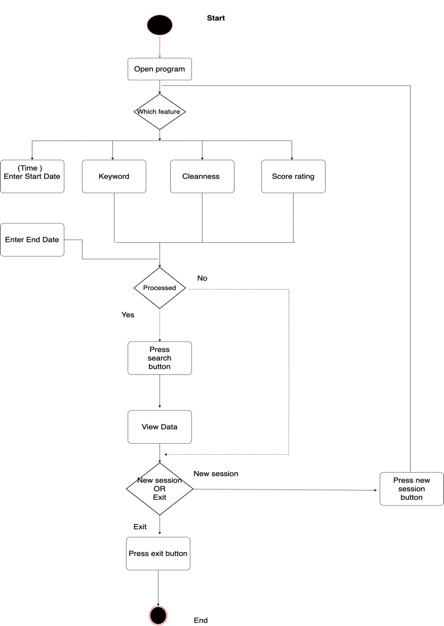

## System Components

### Functions

1. F1: loadData
   * This function loads the *Sydney Airbnb Open Data* csv to the SQLite database
   * Parameters:

* CSV file
* SQLite database file name of “Sydney Airbnb Inspection Results" dataset
  + Side effects
* Creation of SQLite database file with "Sydney Airbnb Inspection Results" dataset
  + Return value

1. F2: Connection with SQLite database
   * This function makes a connection to the SQLite database containing the "*Sydney Airbnb Inspection Results*" dataset
   * Parameters:

* SQLite database file name of "*Sydney Airbnb Inspection Results*" dataset
  + Side effects
* The program is now connected to "Sydney Airbnb *Inspection Results*" SQLite Database
  + Return value
* conn (Connection Object)

1. F3: Time
   * This function retrieves inspection details from “*Sydney Airbnb Inspection Results*" dataset within the period of time selected by the user.
   * Parameters:

* conn: connection object to sqlite database
* startDate, format: dateTime
* endDate, format: dateTime
  + Side effects
* Change in global variable: startDate
* Change in global variable: endDate
* Change in global variable: output
  + Return value
* output: SQLite query to retrieve Airbnb details in the given time period selected by the user from the database

1. F4: Keyword
   * This function retrieves keywords searching from the “*Sydney Airbnb Inspection Results*" dataset that contains the keyword entered by the user (such as pet, pool)
   * Parameters:

* conn: connection object to SQLite database
* keyword, format: String
  + Side effects
* Change in global variable: keyword
* Change in global variable: output
  + Return value
* output: SQLite query to retrieve Sydney Airbnb inspection details with setting keywords that entered by the user

1. F5: Cleanness
   * This functions cases from the “*Sydney Airbnb Inspection Results*" dataset that is related to cleanness selected by the users, such as (clean, shower, carpet)
   * Parameters:

* conn: connection object to SQLite database
* keywordcleanness, format: String
  + Side effects
* Change in global variable: keyword (cleanness)
* Change in global variable: output
  + Return value
* output: SQLite query to retrieve cases related to cleanness determined by the user from the database

1. F6: Score rating
   * This functions cases from the “*Sydney Airbnb Inspection Results*" dataset that is related to score rating time period selected by the user.
   * Parameters:

* conn: connection object to SQLite database
* keyword, format: String
  + Side effects
* Change in global variable: propertyname
* Change in global variable: output
  + Return value
* output: SQLite query to retrieve Airbnb score details in the given property name by the user from the database

1. F7: Visualisation
   * This function displays the output from Time function, demonstrate line chart for the distribution of price of property only
   * Parameters:

* output, format: string (of SQL query)
  + Side effects
* Change in the plot displayed by the program
  + Return value
* Display using wxPython

1. F8: Displaying listing
   * This function displays all properties listing according to the input dates.
   * Input parameters: startDate(int), endDate(int)
   * Side effects: change both parameters
   * Return listing of all properties available according to input parameters
2. F9: Communication display
   * Display communication-related insights for a property.
   * Input parameters: property(string), owner(string)
   * Side effects: none
   * Return communication bubble

10. F10: Booking

* + Booking process for a property by a user within specified dates
  + Input parameters: property(string), startDate(int), endDate(int), status(string)
  + Side effects: none
  + Return the status of the booking

### Data Structures / Data Sources

1. Output
   * Type: list
   * This data structure records the output of SQL query from functions related to the program features
   * Data member: Queries related to Id, name, Listing-id, summary-id, reviewer-id, reviewer-name, comments, review-scores-rating, review-scores-cleanliness, date, neighborhoods, neighborhoods group, neighborhood-cleansed, neighborhood- group-cleansed, room type, price, weekly price, number of reviews, host-Id, host name, description.
   * Functions: F3, F4, F5, F6, F7
2. SYD Airbnb dataset
   * Type: Open Data Source (SQLite database)
   * This is the main dataset used in this program to retrieve all the data that is going to be analyzed and visualized by the app for the user through queries. This dataset is stored in SQLite file external to the python file.
   * Data member: Queries related to Id, name, Listing-id, summary-id, reviewer-id, reviewer-name, comments, review-scores-rating, review-scores-cleanliness, date, neighborhoods, neighborhoods group, neighborhood-cleansed, neighborhood- group-cleansed, room type, price, weekly price, number of reviews, host-Id, host name, description.
   * Functions: F3, F4, F5, F6, F7,

***Extra, Data types:***

1. *startDate*
   * *Type: dateTime*
   * *This is the data structure that records the date range specified by the user*
   * *Functions: F3*
2. *endDate*
   * *Type: dateTime*
   * *This is the data structure that records the date range specified by the user*
   * *Functions: F3*
3. *keyword*
   * *Type: string*
   * *This is the data structure that records the keyword specified by the user*
   * *Functions: F4*
4. *Keyword cleanness* 
   * *Type: string*
   * *This is the data structure that specifically records the keyword of cleanness specified by the user*
   * *Functions: F5*
5. *Score rating*
   * *Type: string*
   * *This is the data structure that records the score rating specified by the user by searching name of property*
   * *Functions: F6*

### Detailed Design

* Pseudocode for "list all information within the time period" feature:
* startDate=(input)  
  endDate=(input)
* Pass the values into the details based on time function
* Receive the output

**If** output is empty:

Display "No results found"

**Else**:

Pass the output into display function

* Pseudocode for "Plot price of property within the time period" feature within the time period" feature
* startDate=(input)  
  endDate=(input)
* Pass the property price values into visulisation function
* Receive the output

**If** output is empty:

Display "No results found"

**Else**:

Pass the output into line chart function

* Pseudocode for "Retrieve keywords within in given time-period by user input" feature
* startDate=(input)  
  endDate=(input)  
  keyword= “string”
* Pass the values into the keyword function
* Receive the output

**If** output is empty:

Display "No results found"

**Else**:

Pass the output into display function

* Pseudocode for "Retrieve keywords related to cleanliness" feature
* cleanlinessInsight=('input’)
* Pass the values into the cleanness function
* Receive the output

**If** output is empty:

Display "No results found"

**Else**:

Pass the output into display function

* Pseudocode for " Retrieve cases within a scores-rating" feature
* propertyName= “string”
* Pass the values into the score rating function
* Receive the output

**If** output is empty:

Display "No results found"

**Else**:

Pass the output into display function

# User Interface Design

To shape the user interface of our Sydney Airbnb project, we decide to implement the app’s design on Canva. Canva is well-known as a user-friendly tool that assists users in designing. It provides shapes, elements, graphics and suggests various of templates that boost our idea in the UI design. For Sydney Airbnb App, we choose to create a minimalism app, using four basic colours, namely: white, grey, chlorophyll, and black. Throughout the design, we visualise the main functions in detail in order to illustrate the app as a user-friendly platform. Our application approaches to the customers with user-centric features and a commitment to enhance their experiences.

## Structural Design

The structural design of the Sydney Airbnb application ensures seamless user experience that allows customers easily come across the app. The outline design (section 4.2) demonstrates Sydney Airbnb application that help users book a place to stay in their desired destinations and travel dates. It visualises most of use cases that defined in section 2.3 and met all requirements in section 2.2. Our aim of design is to characterise logical group of information, navigation, and to demonstrate a comprehensive hierarchy that satisfy the customer’s UXUI demand.

Interface structure:

* Consistency: Throughout the application, structure and layout are illustrated in similar design whether the customer use Mac or Window laptop. It is created to be unified and predictable for better user experience. Additionally, it enhances usability objectives and brings more success outcomes.
* Labels and headings: “Sydney Airbnb” will be edited in bold and always placed in the left corner so as to highlight the company’s name. Headings are edited larger and filled in contrast colour in most page layouts, so the customer effortlessly recognise the main function/ purpose when navigate to new page.
* Fonts and colours: In the Sydney Airbnb application, it is divided into four different fonts for four roles: the company’s name, headings, sub-headings, property’s information. We tend to design a minimalism booking application. Thus, simply we choose shades (black and white) with little grey and take green as a highlight.
* Distribution: Every page layout contains its own function. It will be no (or less) confuse when customer is navigated to a new page. In general, there are 9 layouts in total: home page, properties searching, properties browsing (already includes price sorting and keyword finding), detailed property viewing, messaging, requesting, booking, confirming, and customer feedbacks and reviews.

Grouping information: Our grouping strategy mainly focus on as much user-friendly as possible. In “sorting price” function, the app allows the customer to sort available list of properties either in ascending or descending order. We also paraphrase and add icons to show their own functions. Similarly, small profile picture in the top-right corner groups up customer’s account details (ability to sign up and sign in) and customer can make a request. Furthermore, the “search” section allows customer to filter property in typing keywords. The app will show suitable results related to keywords.

Navigation strategy:

* The homepage will welcome users with an image background, the app’s name and at the top right will be the sign-in button. To get to the search page, users will have to click anywhere on the homepage.
* The search page will contain the search inputs such as the destination, dates, and the number of people. After users input everything, they will have to click on the search button to access the search results page.
* The search result page will contain every property available that correspond to the users’ inputs. Then, users can sort the properties by prices, and they can also search properties containing a specific keyword.
* Property page will contain all details, photos, and reviews of the property the user has clicked on. They can also contact the owner for additional information about their property.
* Communication bubble is the page where user will be able to communicate with the owner.
* Booking page is the page where users can book their property by including their personal information, the dates, and the number of people.12

Final decision: Our design leads to the aim of functionality and simplicity while using the Sydney Airbnb application. The interface structure generally aligns with user-centred approach which makes it user-friendly so that the majority if users can use it without any troubles and difficulties.

## Visual Design

At the storyboard 1, there is a user interface of welcoming page that user has downloaded and installed to their computer. There are three options for customer before using the app. They can start access Sydney Airbnb as a guest. They also decide to join us as a member simply by register an account. If the customer already signed up, they can login to their account again that has saved searching history, wish list, etc.

  
Figure 1. Storyboard 1.

In the storyboard 2 below, the app allow customer to enter their desired destination, travel dates and number of people. The system automatically searches and filters to meet their requirements with most updated properties.

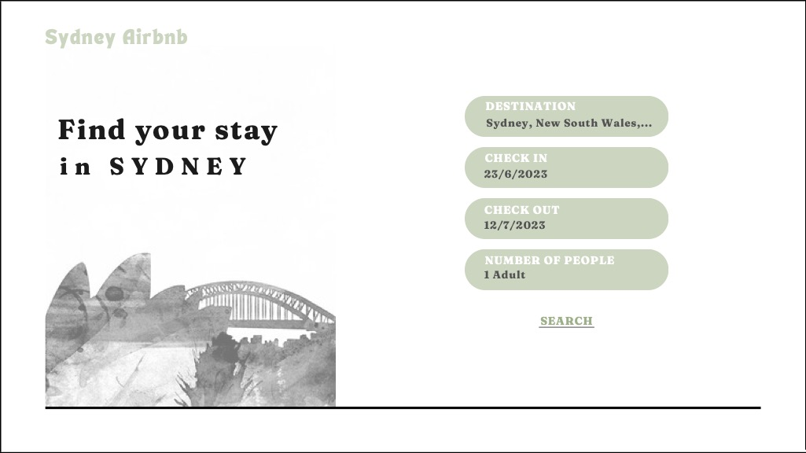  
Figure 2. Storyboard 2.

In this storyboard 3.1, the customer is now navigated to the browsing page that they can generally view the list of properties with basic needed information. They can resume important keywords of their search (destination, dates, amount of people). The list is viewed by either sliding to the right or scrolling down.

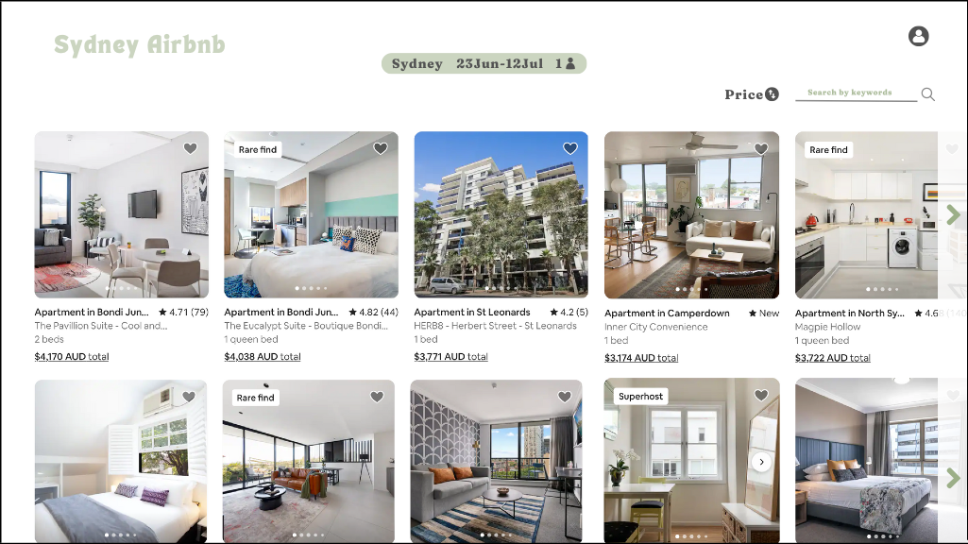  
Figure 3. Storyboard 3.1.

In this storyboard 3.2, the customer can sort the list by price in either ascending or descending order. The app automatically changes to suit their needs. Additionally, they can type any keywords to search properties. Matching results will be listed on top.

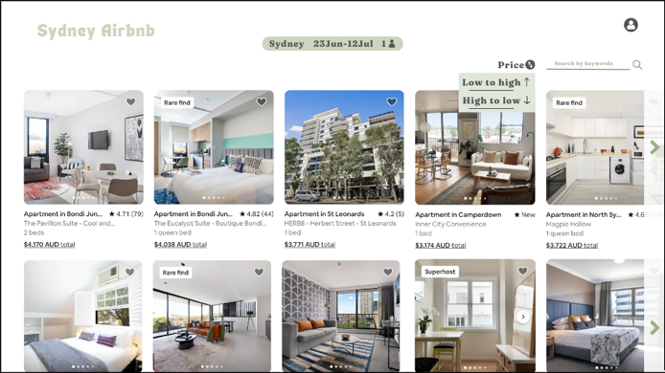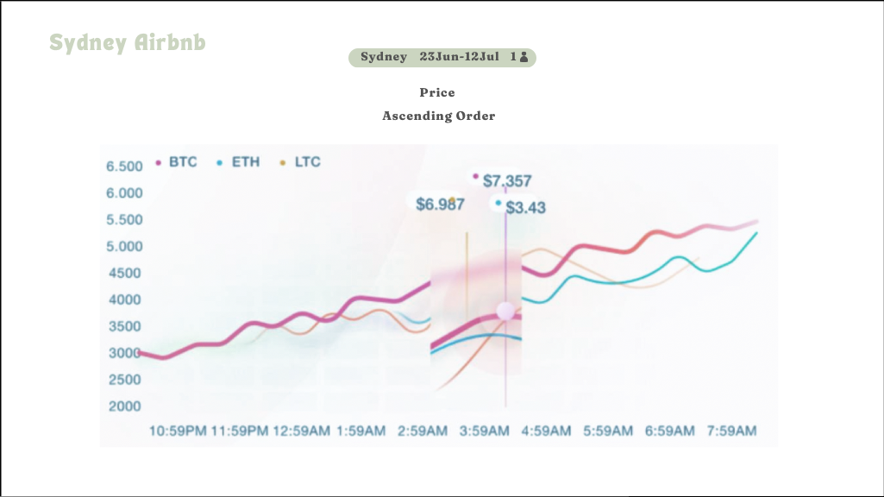  
Figure 4. Storyboard 3.2.

This storyboard 3.3 describes a profile that is placed in top-right corner. The customer is allowed to join “Sydney Airbnb” at any time by sign up. If they forget to login the application, they can immediately sign in. Furthermore, whether they are guest or member, they can make a request due to changes in booking, inspection, etc.

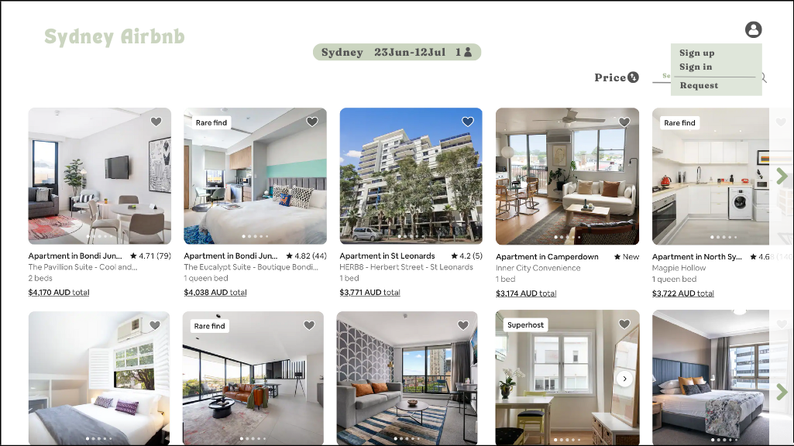  
Figure 5. Storyboard 3.3.

The detail of request form is indicated in storyboard 3.4. The customer is required to fill in their information and send their request with appropriate reasons. The customer’s request will be sent to admin, and they will process whether to approve or decline. A responded email will be sent to the customer in 3-5 business days.

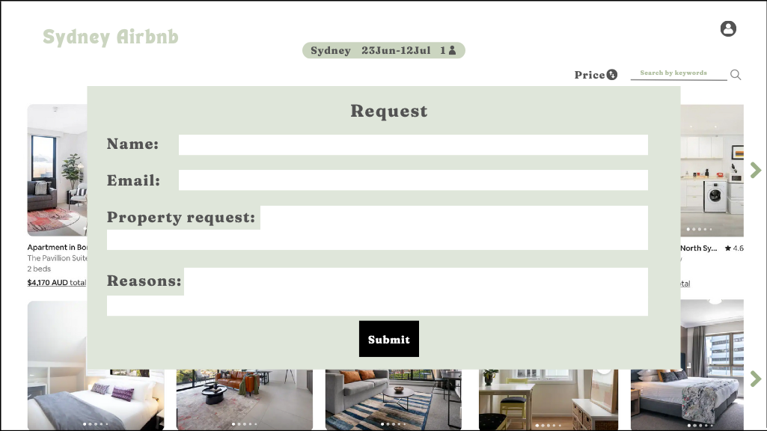  
Figure 6. Storyboard 3.4.

After browsing the list of properties, the customer can access to any specific property to view it in detail (storyboard 4.1). They can add to their wish list by simply pressing “Save” button. When the customer scrolls down, they will see summary detail on the right, and they can proceed to booking or have a conversation with the property’s owner.

  
Figure 7. Storyboard 4.1.

In the same page, after viewing detailed information of a property, the customer can view feedbacks and reviews on that property (storyboard 4.2). The application already collects and analyses information of cleanliness, and other facilities based on customers’ feedbacks and reviews.

  
Figure 8. Storyboard 4.2.

In this storyboard 5, the customer is navigated to a new page – messages, where they can have a direct message with the property’s owner.

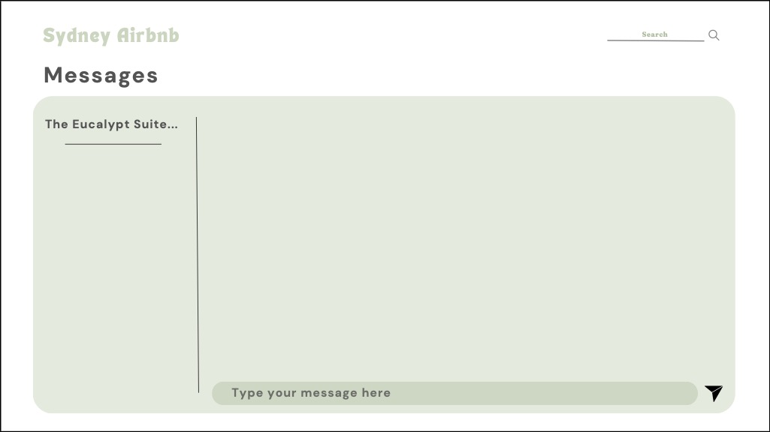  
Figure 9. Storyboard 5.

The customer decides to book a property for their stay, they are navigated to storyboard 6. The customer is required to fill their personal information which is protected by a third party.

  
Figure 10. Storyboard 6.

A successful message will be announced after submitting your personal details (storyboard 7). A booking confirmation is also sent to your email.

  
Figure 11. Storyboard 7.

In storyboard 8, after experiencing your stay, “Feedbacks and reviews” will be sent to your email and when you open the application again. The app will collect and analyse data to show each property’s rating for better user experience.

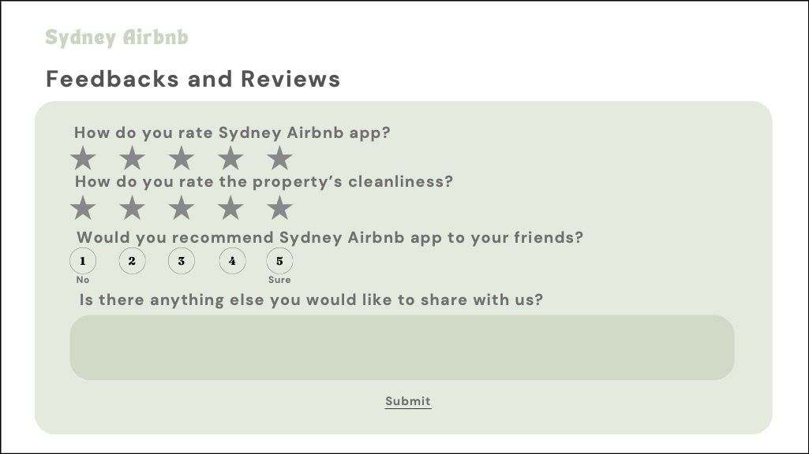  
Figure 12. Storyboard 8.